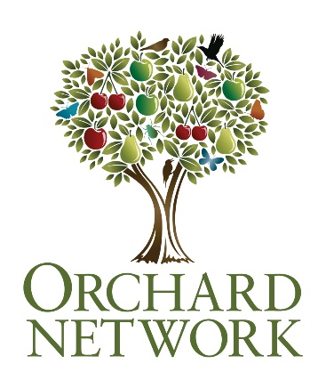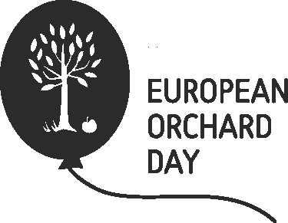

Orchard Blossom Day

Blossom has mostly disappeared from our lives. This new celebration will bring it back.

Events can be in April or early May, or whenever you think your blossom will be at its best.

This information can help you take part.

Register your venue and invite people to come along for a special day out.

Blossom is good for wildlife, good for the soul, and absolutely essential for fruit production, so when your orchards or fruit trees are at their best, open your orchard up to the local community, hold a special event, take a walk amongst blossom trees, and join the celebration on social media channels, or just quietly enjoy the best that nature has to offer. Orchard Blossom Day will be celebrated every year – so if you can’t do anything this year, plan ahead for the next one. Use these four resources to help plan your event.

- The first thing is to think about what you can do. Have a look in the Guide to organising Orchard Blossom Day events and activities for ideas.

- The next action is to register the event with the Orchard Network
www.orchardnetwork.org.uk/orchard-blossom-day

Follow the link to register a venue.

IMPORTANT: This will only provide a pin on this map – this will need to link to your own website, Facebook page, or poster, ideally with information about your event. Add information to your internet presence, or make a poster using this template (or indeed make one of your own). Place this on a shared drive and create a download link for us to use, or send it to us and we can put it online.

- Create some content on your web presence or make and share a poster:

Here’s some text you might find useful:

Short text:
Orchards across the nation will open their gates to visitors for Orchard Blossom Day around the end of April, offering tours and activities, orchard produce and a chance to enjoy the beauty of fruit tree blossom. Find your local open orchard or discover more about heritage orchards at www.orchardnetwork.org.uk.

Medium text:
Orchards across the nation are preparing to open their gates for Orchard Blossom Day. This new annual celebration of fruit trees, flowers and food launches across the UK and Europe around the end of April. The Day is celebrating orchards as magical places for the benefit of people and nature, places of a huge but dwindling variety of fruit trees and places in need of conservation across Britain and Europe. Find your local open orchard or discover more about heritage orchards at www.orchardnetwork.org.uk.

Long text:
Orchards across the nation are preparing to open their gates for Orchard Blossom Day supported by the many organisations that comprise the UK Orchard Network. This new annual celebration of fruit trees, flowers and food launches across the UK and Europe around the end of April when blossom is at its best. Be part of it and enjoy the day - at home, at an event, or just out and about.

Events may include picnics, tours and activities, orchard produce to taste and buy, and the simple pleasure of walking amongst the blossom. Blossom Day is partly for the joy of celebrating orchards as magical places for the benefit of people and nature, and appreciating what an important local resource they are for local food production using wildlife friendly methods.

Orchards are places where lots of different sorts of fruit trees grow, from the familiar apples, pears, cherries and plums, to the less widespread, greengages, nuts, medlars and quinces, all having many different varieties but they are under threat and are in need of conservation. Events will take place all over Europe - from Britain to Tyrol, from Transylvania to the Atlantic.

This new Day will complement the hugely popular Apple Day events in September and October started by Common Ground in 1990 to celebrate the apple harvest in all its variety.

Find your local open orchard or discover more about heritage orchards at www.orchardnetwork.org.uk.

Logos can be downloaded from here:

Orchard Network

European Orchard Day

Images free use for Orchard Blossom Day publicity only (otherwise various copyrights apply) can be downloaded from here:
Images

Some samples of images you can get from the shared drive above:

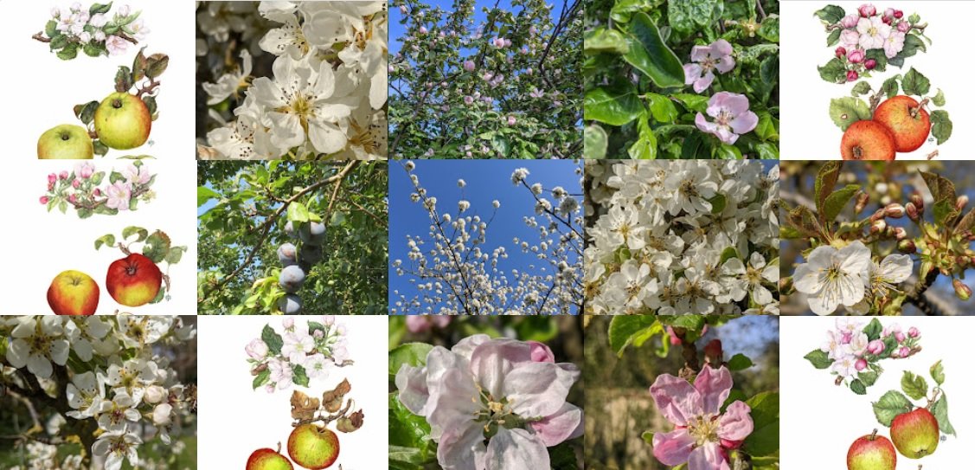

- Signpost your social media to the following:

- #OrchardsEverywhere
- #BlossomWatch
- @UK_Orch_Network
UK_Orchard_Network

